UCLA Bruinracing 2019

**Major Components**

1. Battery Connections

2. Horn Connections

3. Motor Driver

Switch Fuse with Wires (buck to 12V and 10V)

Internal and External Switch (measure and wire)

**BATTERY CONNECTIONS**



Wires (connection to connection / color / distance)

1. Solder to solder / / short
2. Solder to solder / / short
3. Solder to ring / / short
4. Solder to ring / / <-add fuse
5. Ring to solder / /
6. Solder to ring / /

**HORN CONNECTIONS**



Wires (connection to connection / color / distance)

1. Ring to Solder / blue / 45in
2. Solder to Clip / blue / 40in
3. Clip to Ring / blue / 85in

**MOTOR**

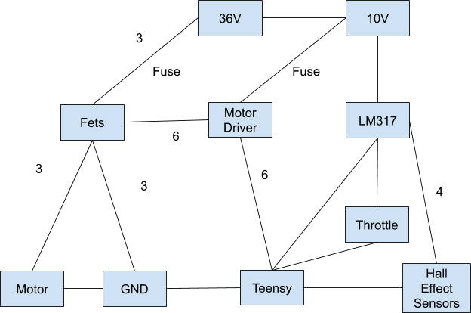

**Wires**

-12AWG: 36V->Fets, Fets->Motor, Motor->GND, Fets->GND, 10V->Motor Driver

-22AWG: 10V->LM317, LM317->Teensy, LM317->Throttle, LM317->Hall Effect Sensors, Teensy->GND, Teensy->Throttle, Teensy->Hall Effect Sensor, Teensy->Motor Driver, Motor Driver->Fets

**NOTES**

* 12V buck has black connector, 10V buck has green connector